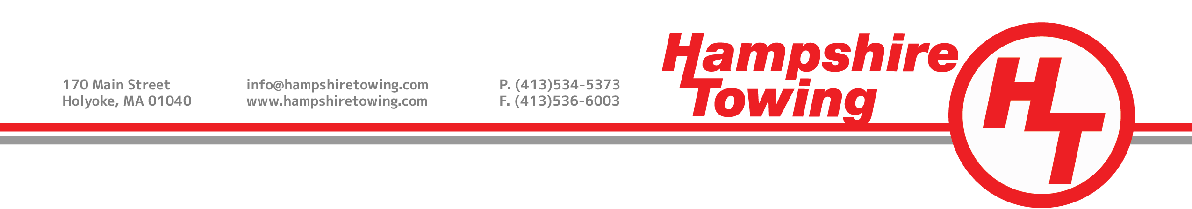

Release

I, the undersigned, in consideration of being permitted to enter onto the premises of Pleasant Street Auto Body & Repair Inc., dba Hampshire Towing, property owned by William E. Johnson and Robert E. Johnson, located at 170 Main Street, Holyoke, Hampden County, Massachusetts, on behalf of myself, my heirs, my agents, my representatives, my personal representatives, my employer, my successors and/or assigns, do forever release, acquit, discharge, and covenant to hold harmless Pleasant Street Auto Body & Repair Inc., dba Hampshire Towing, owned by William E. Johnson and Robert E. Johnson, located at 170 Main Street, Holyoke, Hampden County, Massachusetts, its employees, servants, agents, owners, representatives for any and all actions, rights of actions, causes of actions, charges, and/or claims, in any way related to, arising from and/or growing out of, directly or indirectly all known or unknown personal injuries, property damage, or death, which I may now or hereafter have, in consideration of entering onto the aforementioned premises, I, for myself, my heirs, my agents, my representatives, my personal representatives, my employer, my successors and/or assigns in interest agree to waive, release, discharge and hold harmless and promise to indemnify Pleasant Street Auto Body & Repair Inc., dba Hampshire Towing, property owned by William E. Johnson and Robert E. Johnson, located at 170 Main Street, Holyoke, Hampden County, Massachusetts, its agents, employees, members, officers, directors, owners from and against all loss, damage, cost, liability of every kind and nature, arising directly or indirectly from my entering onto the aforementioned premises.

THE RELEASE IS A CONTRACT WITH LEGAL CONSEQUENCES AND I HAVE READ IT CAREFULLY BEFORE EXECUTING THE SAME.

EXECUTED as a sealed instrument on this ________________ day of __________________________________.

Witness: __________________________________________________________________________________

Printed Name: ______________________________________________________________________________

