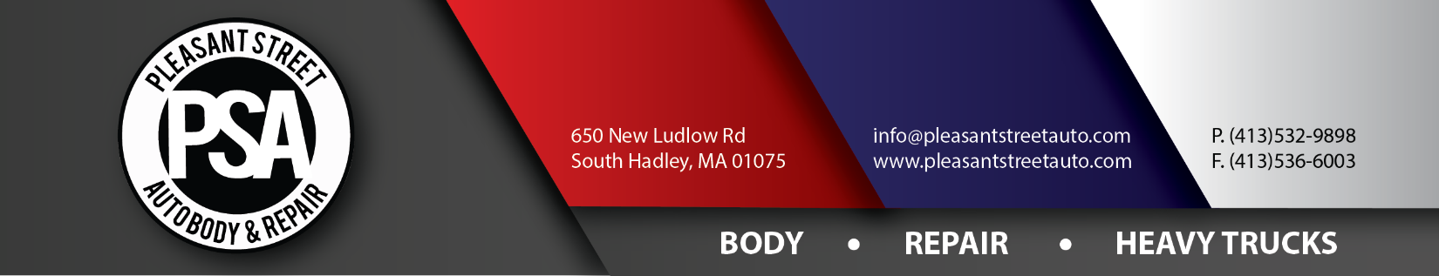
Assignment of Rights
I, ___________________________________ (hereinafter referred to as “Assignor”), or _____________________________________, hereby assign to Pleasant Street Auto Body & Repair Inc., dba Hampshire Towing (hereinafter referred to as “Assignee”) of ________________________________________, for valuable consideration and the amount of _________________________________ ($_________________) dollars, the receipt of which is hereby acknowledged, all my right, title, and interest with respect to any claims, other than personal injury claims, I know have and more particularly any rights I may have under any insurance policy or policies or contract between ___________________________________ and myself which provides coverage in connection with a motor vehicle incident which occurred on or about ___________________ in _________________________________.
Now therefore, Assignor and Assignee agree as follows:
Assignor and Assignee hereby acknowledge the receipt by this Assignment of all the Assignor’s rights and benefits as aforesaid.
Assignee hereby accepts this Assignment of all the Assignor’s benefits, rights, obligations, responsibilities, and duties under a certain Contact between the Assignor and the Assignee with respect to the incident which occurred on or about __________________________________ and services rendered subsequent to that date as to any outstanding amounts or sums due to the Assignor from the Assignee.

Assignor (Please Print): _______________________________________________________________________
Signature of Assignor: ________________________________________________________________________
Assignee (Please Print): ______________________________________________________________________
Signature of Assignee: _______________________________________________________________________

