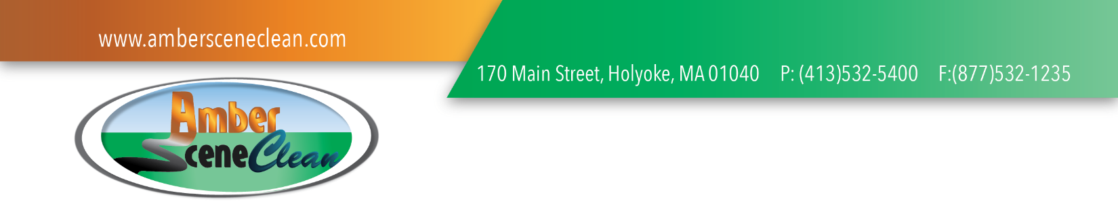
Direction to Pay – Property Damage
In full accordance with the M.G.L. Ch. 21E & 310 CMR 40.000
Tax ID: 043051307

To Whom It May Concern,
As the responsible party, I hereby authorize direct payment for all services rendered on my behalf from my insurance company and/or any other responsible party, payable to Amber Scene Clean for the required services regarding any illicit discharges or services to prevent such discharges from impacting the environment. Without admitting any guilt or responsibility for the accident itself, I understand that in accordance with the Federal EPA and Massachusetts DEP Regulations, any illicit discharge of contaminants and hazardous fluids that my vehicle emits must be contained, collected, and disposed of properly in accordance with all applicable laws. I understand that, ultimately, I am responsible for this service and costs occurred.
Vehicle Owner: _____________________________________________________________________________________
Address: ___________________________________________________________________________________________
City: ________________________________________ State: ____________ Zip Code: ________________________
Vehicle: _____________________________________ Model: ______________________________________________
V.I. #: _____________________________________________________________________________________________
Incident Location: ________________________________________________ Incident Date: ______/_______/______
Insurance Company: _________________________________________________________________________________
Claim #: ________________________________________________________ ASC Inv. #: _______________________

Signature: _________________________________________________________________________________________

